AFS Saginaw Valley Chapter Foundry in a Box 2019-2020 events

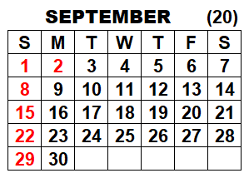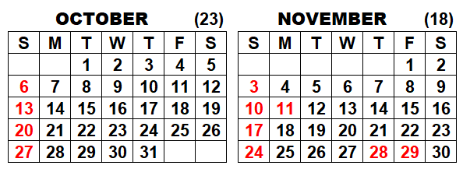
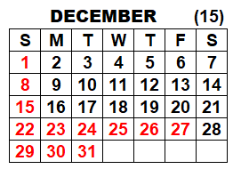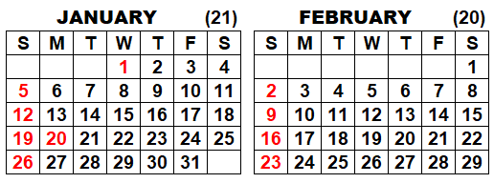
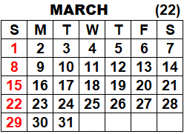
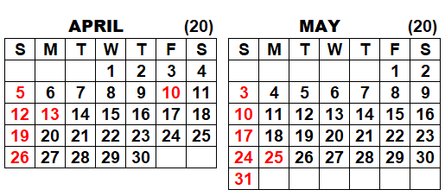
Confirmed date tentative date Easter is April 12, 2020

CANCELLED Events (due to Covint-19 virus emergency)
Delta College Girls Day Out STEM Friday April 17 7:30 AM to 2:30 PM (groups every 25 mins)
Clarkston Maker Faire (aid DTW AFS) Saturday, April 18 8:30 -11:30 AM and 12:30-2:30 PM (525 girls)
GM Customer Cares Take Kids Work Thursday, April 23 10:00 AM to 2:30 PM
Hemetter SPARK STEM day Friday, May 8
Nouvel Catholic Central Elementary Friday, May 15

Completed Events
Mid-Michigan Museum Touch a Truck Saturday September 21, 2019 from 9:30 AM to 4:00 PM
Vassar Elementary School Friday, October 18 from 8:30 AM to 11:30 AM (5th graders)
Vassar Elementary School Friday, October 18 from 8:30 AM to 11:30 AM (5th graders)
Bay City Handy Middle School Wednesday Nov. 6 & Nov 13 from 7:00 AM to 2:30 PM (7th graders)
Bay City Western Middle School Tuesday, Nov 19 & Nov. 26 from 7:00 AM to 2:30 PM (7th graders)
Robert Kerr Elementary School, Durand Tuesday, Dec 3 8:30 AM to 3:00 PM (5th & 6th graders)
BSA Cub Scouts (Rob Tuttle) Saturday, Dec. 14 4:00 to 7:00 PM
Haven Elementary School Wednesday January 22, 2020 8:30 AM to 3:30 PM
Lake Orion MakerFaire (aid DTW AFS) Saturday March 7 8:00-9:30 AM and 10 AM-11:30 AM

Cramer Junior High in Essexville date TBD
Freeland SportsZone (after school in Summer or Christmas holiday)

The DELTA 2019 STEM Festival event not to be held October 2019 (maybe in spring 2020 at SVSU)

